Homework #5
# Due date: 23/Nov, 23:59:59
# Submit a zipped file of your application project folder
# In the application source, you MUST give comments for important lines. Without comments, your solutions will be considered copy&paste codes.
# Put your answers in “AnswerSheet” section
# You must use Kotlin language.

* Member registration
- Zipped file name should be “fragments.zip”
- Include a short demo video

- You need to make a simple application for membership registration
- Your main activity should be composed of three regions
a) Top – Textview and Button
b) Middle - Fragment
c) Bottom - Fragment

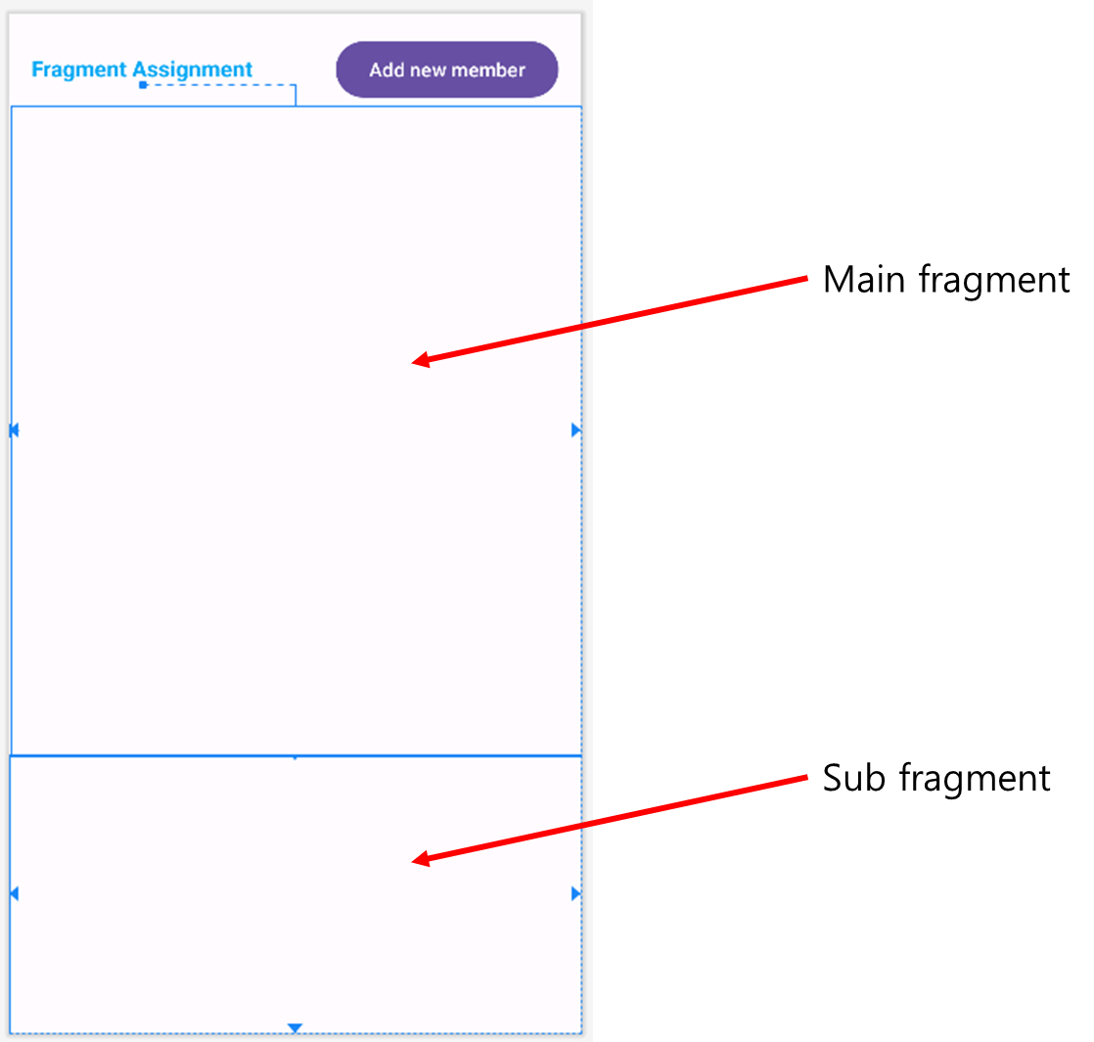

- The usecase for this assignment is as follows:
1) When the application is launched, there should be no UI components in the area for main fragments, while only “Welcome…” message should appear in the sub-fragment, like the below figure:
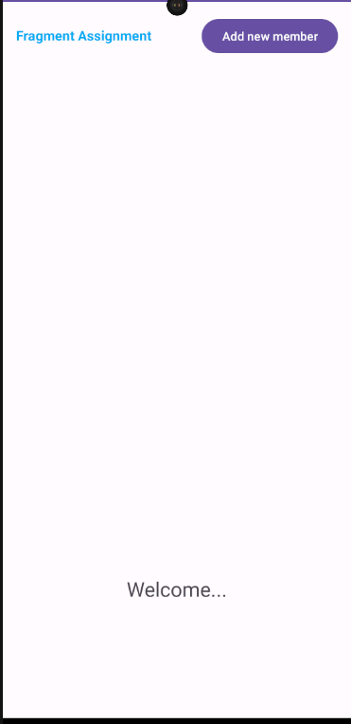

2) If a user touches the “Add new member” button, then the fragment to input personal information should be loaded and displayed in the middle area:

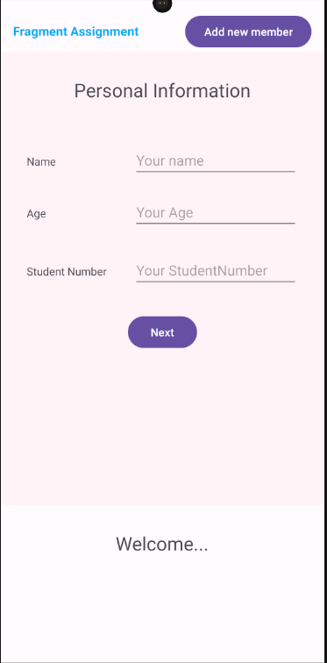

3) After filling in the forms, the user will touch “Next” button. Then, another fragment to input address information should be loaded and displayed in the middle area. At this time, the user’s information (name, age, and student number) should be passed to the Activity.
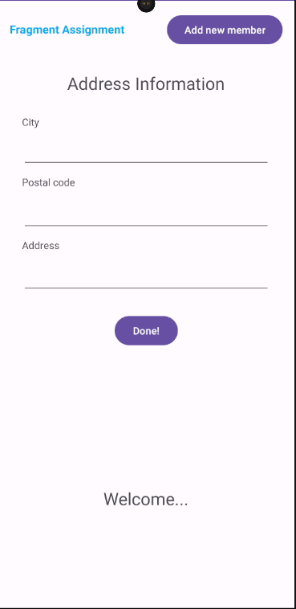

4) After filling in the forms, the user will touch “Done!” button. Then, the fragment at the bottom should display “Registraiton Confrimed!” message and user’s name, “Please review your data!” text with red colored, and the user’s student ID, age, and City data. At this time, the user’s information (city, postal code, and address) should be passed to the Activity. Afterwards, the activity needs to pass student information to the sub-fragment, so that the sub-fragment can display the information mentioned above.

Example is as follows:
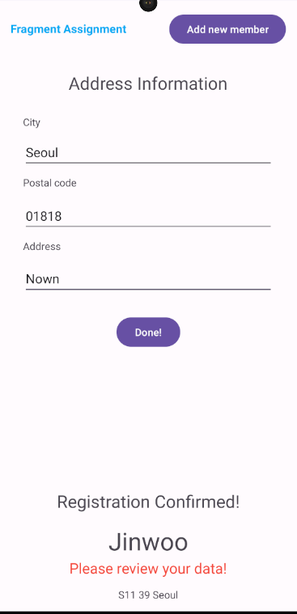

- Workflow of this assignment is as follows:

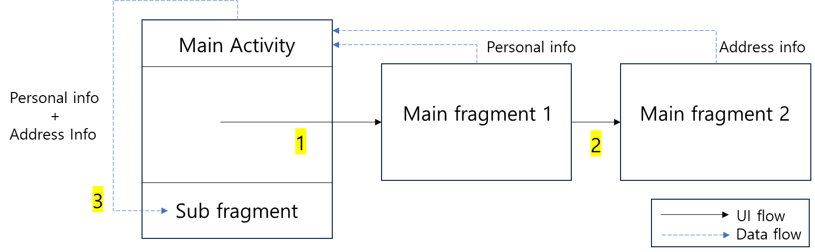

- Some notes
1) Use Google Drive to submit the assignment in case the file size exceeds the eClass limit.
2) Data transfer from fragments to activity should be implemented using interfaces.
3) No restrictions on data transfer from activity to fragment
4) You need to determine how to store user data by yourself. For example, you can use data class to define Student information.
5) UI details depends on your style and preferences
6) Refer to the attached demo video file

AnswerSheet – Short Analysis of your code
- Explain how your activity and fragments share the data

Fragment → Activity: Callback Interface
- MainFragment: Defines the Callbacks interface. On "Next" button click, it reads the name, age, and student ID from input fields and passes them to the Activity.
- AddressFragment: Follows the same pattern. On "Done" button click, it passes the city, postal code, and address.
- Connection Process: In the Fragment's onAttach(), the context is cast to Callbacks to connect the callback. In onDetach(), the callback is set to null to prevent memory leaks.
Activity → Fragment: Calling Public method
- MainActivity: Stores the personal information and address information in a UserInfo data class.
- SubFragment: Provides a public method: updateInfo(userInfo: UserInfo).
- Data Passing: In onDoneButtonClicked(), the Activity finds the SubFragment instance and calls updateInfo(userInfo).
- Data Display: SubFragment reads the information from the UserInfo object and displays it on the screen.
Summary Flow
- MainFragment → (Callback) → MainActivity: Save name, age, student ID
- AddressFragment → (Callback) → MainActivity: Save city, postal code, address
- MainActivity → (Method Call) → SubFragment: Pass and display the completed UserInfo

